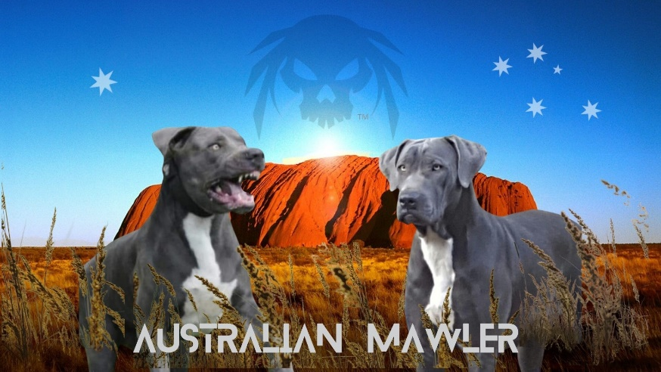
BIN NO.0000946714612
CRM 0271014
PET HOME PUPPY APPLICATION
Thank you for your interest in our breed and puppies. As you could appreciate, we are very particular to whom our puppies go to for their forever home.
Therefore, please complete our application and review and agree to our terms and conditions to move forward to having a Australian Mawler puppy as part of your family.
Please return application and T&C agreement to the details at the bottom of this page.

APPLICANTS DETAILS

NAME: ……………………………………………………………………………………………………………

ADDRESS: …………………………………………………………………………………………………………….
.…………………………………………………………………………………………………………….

PH NO: .…………………………………………………………………………………………………………….
EMAIL: .……………………………………………………………………………………………………………..

QUESTIONNAIRE

- Please describe your living circumstances, do you have secure accommodation is it fully fenced if so what type of fence?
Property Size etc?

- Have you ever owned a large breed dog before and if so what breed?

- Do you own any other animals if so what type?

- If you are approved for one of our puppies are you prepared to partake in obedience training?

- Have you ever turned an animal into a rescue shelter? If so why?

- Have you considered the financial cost of dog ownership and are you prepared to give your new puppy/dog the medical care, quality food, training, grooming etc for its lifetime?

- As part of our breeding program we require all owners to stay in contact and send regular updates and photos of progress at least every 3mths are you prepared to do that?

- Please explain briefly why you are interested in having one of our puppies in your family and what the main purpose i.e. family pet, personal protection or guard etc

Applicant Name:
Signature:
Date:

TERMS AND CONDITIONS

- After you have been approved for one of our puppies, we require a $500 non refundable deposit to secure your puppy and the balance to be paid in full before pup is transported.
Deposit will be refunded if seller terminates purchase.
- Transport costs are included in price to all capital cities or anywhere on the East Coast Cairns to Melbourne.
- Once you purchase your puppy/dog you 100% agree to take full responsibility for the dog its well being and behaviour both in the home and outside environments.
- At least 3 monthly updates and photos on how your puppy/dog is progressing if possible to ensure their safety and well being this helps us to make sure they are not being mistreated or mishandled i.e. dog fighting etc.
- Should the puppy/dog become ill or unsound after ownership, any and all of the cost will be the responsibility of the buyer.
- These puppies are for pet homes only unless approved by seller, in this case an extra fee will apply along with a separate terms and conditions form to be completed.

This is a legal binding document and by signing this you agree to the above terms and conditions.
All of the information I have given in both the application and terms and conditions agreement is true and correct. This dog will reside in my home as a pet. I will provide it with quality dog food, plenty of fresh water, indoor shelter, affection, annual physical examination and vaccination under the supervision of a licensed veterinarian.

Full Name:

Address where dog will be homed:

Phone no:

Email:

Signature of Owner Signature of Breeder

